REGISTRATION FORM
FOR OFFICIAL USE ONLY:
Amount received: HK$ _____________________ Registration No.: _________________ Receipt No._______________

The 2nd ICIS & HKCR Cancer Imaging Meeting
“Cancer Management: From Diagnosis to Treatment”
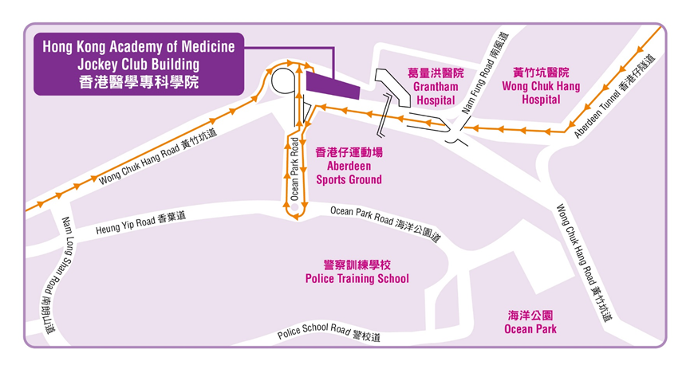
31st January - 1st February 2015 (Saturday & Sunday)

Venue: Hong Kong Academy of Medicine Jockey Club Building
99 Wong Chuk Hang Road, Aberdeen, HKSAR, China
香港黃竹坑道99號香港醫學專科學院賽馬會大樓
www.hkam.org.hk

(Each form should be used for one registration only. It can be photocopied, downloaded from http://www.icimagingsociety.org.uk or http://www.hkcr.org or obtained from the HKCR secretariat office.)

Please return the completed registration form with payment to:
Conference Department  Hong Kong Academy of Medicine  Room 808, 8/F, HKAM Jockey Club Building  99 Wong Chuk Hang Road  Aberdeen, Hong Kong SAR, China  Attention: Registration Secretariat of 2nd ICIS & HKCR Cancer Imaging Meeting |  | Tel: (852) 2871 8787  Fax: (852) 2871 8898  Email: HKCR@hkam.org.hk  Please visit our website for updated information:  URL: http://www.icimagingsociety.org.uk or http://www.hkcr.org

I. Identification (please use block capitals)
Title: Prof. / Dr. / Mr. / Mrs. / Ms. Status: Fellow / member of ICIS / HKCR:  YES  NO
Last Name: |  |  |  |  |  | First Name:
Position: |  |  |  |  |  | Department:
Organization / Institute:
Mailing Address:
Telephone: |  | ( ) |  |  |  |  | Facsimile: | ( )
E-mail address:

II. Registration Fees & Method of Payment
Registration fees for delegates include a copy of programme book, coffee breaks and lunch(es) during the meeting period. Conference kits are for full registrants only. All bank charges must be pre-paid.
REGISTRATION FEES FOR LOCAL/OVERSEAS DELEGATES:
 | Fellows & members  of ICIS / HKCR | Radiographers, Medical Physicists and Nurses | Other Physicians | Students
Full Registration (2 Days) | - HKD 2,000 /  - USD 300 | - HKD 1,500 /  - USD 225 | - HKD 2,500 /  - USD 375 | - HKD 1,000 /  - USD 150
Day Registration (on ________ ) | - HKD 1,000 /  - USD 150 | - HKD 750 /  - USD 113 | - HKD 1,250 /  - USD 188 | - HKD 500 /  - USD 75
(The registration fees in USD as quoted above include bank charges.)

METHOD OF PAYMENT:
- Cheque in Hong Kong Dollars (HKD) made payable to “HONG KONG ACADEMY OF MEDICINE” enclosed. For overseas delegates, personal cheques are not accepted.
- Bank Draft in US Dollars (USD) made payable to “HONG KONG ACADEMY OF MEDICINE” enclosed.
- Payment by Credit Card in Hong Kong Dollars (HKD) for overseas delegates only. The following credit cards are accepted: VISA, MASTERCARD.
Please charge the total amount above to the following credit card:  Visa  MasterCard

Cardholder Name:
Credit Card No.: |  | Expiry Date: | ( mm / yy )
Cardholder Signature: |  | Date:

NOTE: Your registration will not be processed or confirmed if payment is not forwarded with this form.

Please encircle the number of your preferred workshop for each AM and PM session:

SATURDAY 31ST JANUARY 2015

AM | 1 | Multiparametric MR imaging of liver malignancies | Jeong Min Lee
AM | 2 | Challenges in head and neck cancer | Harriet C. Thöny
PM | 3 | Lymphoma staging – what clinicians want to know and what we should report | Sarah Vinnicombe
PM | 4 | Diffusion weighted imaging (DWI) in pelvic cancer | Heinz-Peter Schlemmer
PM | 5 | The role of PET-CT in cancer staging | Wim J. G. Oyen
PM | 6 | Multiparametric MRI for planning robotic assisted radical prostatectomy | Giuseppe Petralia

SUNDAY 1ST FEBRUARY 2015

AM | 7 | Setting up lung cancer screening in your hospital – the essentials | Theresa McLoud
AM | 8 | MRI of the post-treatment neck | Ann King
PM | 9 | Role of MRI in characterizing adnexal masses | Anju Sahdev
PM | 10 | How can multiparametric MRI change the management of prostate cancer patients? | Giuseppe Petralia
III. CME/CPD Accreditation
The 2-day meeting is accredited by Hong Kong College of Radiologists for 13 (Cat. A) CME/CPD Credit Points.
[7 points for 31st January 2015 and 6 points for 1st February 2015]

CME/CPD credit points from The Royal College of Radiologists, other Colleges of the Hong Kong Academy of Medicine, MCHK CME Programme and Radiographers Board of Hong Kong are under application.

Please remember to register for your CME/CPD points on both days of the meeting. Programme may be subject to changes.

IV. Personal Data (Privacy) Ordinance
Your name and institute will be included in the list of participants, which may be distributed to delegates, speakers, sponsoring companies and other parties involved in this event and also for our College’s future scientific activities. Please tick box if you do not agree.
I would not like my name to be included in the list of participants. 

V. Cancellation Policy
In the event of cancellation, a refund of the total registration fee paid (minus a 25% administration fee) will be made, on provision of a written notice received by the Secretariat on or before 30th November 2014. After this date, no refund can be made for cancellation. Please note that all refunds will be issued only after the meeting. In case of cancellation due to bad weather or other uncontrollable factors, no refund will be entertained.

Signature: _____________________________________________ Date: _________________________________________

